A report on

**Mess Management System Project**

Submitted by

**ABHIJIT SARKAR(20BCS006) , ABHIRAJ RAM(20BCS009) ,**

**ADARSH KUMAR(20BCS016)**

**CSE, 2021**

Submitted to

**Prof. Pritee Khanna**



PDPM INDIAN INSTITUTE OF INFORMATION TECHNOLOGY, DESIGN AND

MANUFACTURING JABALPUR, INDIA

November 16th , 2021

**Introduction**

Mess management system project is a project to manage all the basic functionalities of any Mess like record register new user, delete user, manage daily attendance, check mess progress etc.

Mess management system project is useful for providing some functionalities online so that users can know about the mess/restaurant like what is the today’s meal, what is tomorrow’s meal, what is the full week menu, user’s feedback and review etc.

**Working of the project**

We have divided mess management system project in two panels –

1. User Panel
2. Admin panel

**1.User Panel**

To use user panel first of all a new user has to registered himself. Once he/she has successfully registered himself, he can login to user panel.

User panel or user dashboard is a page where a user can see or perform some basic functionalities of a user.

Here are some facilities provided to a user –

1. User can check today’s meal, tomorrow’s meal and full week menu.
2. User can edit his/her profile.
3. User can submit feedback.
4. User can check mess timing and important notices.

**2.Admin Panel**

Admin panel is the important and main panel of the project. Here a admin can manage all the basic activities of a mess/restaurant.

Here are some functionalities that admin can do –

1. View all users
2. Delete a user
3. Edit menu
4. Marks daily attendance of all the meals
5. Check the status of today’s attendance
6. Check the status of feedbacks provided by users
7. Check the details of mess staff etc.

**Technology used**

We have used some basic software/tool to create this mess management system project that are listed below –

1. Text editor (Visual Studios)
2. Web browser (Google Chrome)
3. Local server (Xampp server)
4. MySQL database
5. Bootstrap

**Database details**

To record mess management system project data we have user MYSQL database.

**Database tables used**

1. **Admins** – This table is used to store the details of a admin.
2. **Attendance1** – This table is used to store the attendance of meal1.
3. **Attendance2** – This table is used to store the attendance of meal2.
4. **Attendance3** – This table is used to store the attendance of meal3.
5. **Attendance4** - This table is used to store the attendance of meal4.
6. **Feedback** – This table is used to store feedbacks submitted by the users.
7. **Menu** – This table is used to store mess menu.
8. **Users** – This table is used to store all the users.

**RELATIONAL MODEL**

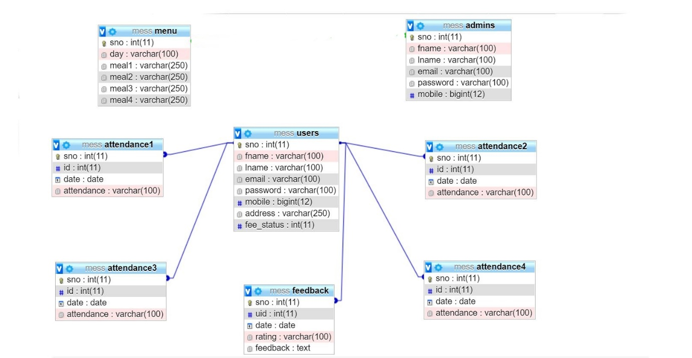

**ER DIAGRAM**

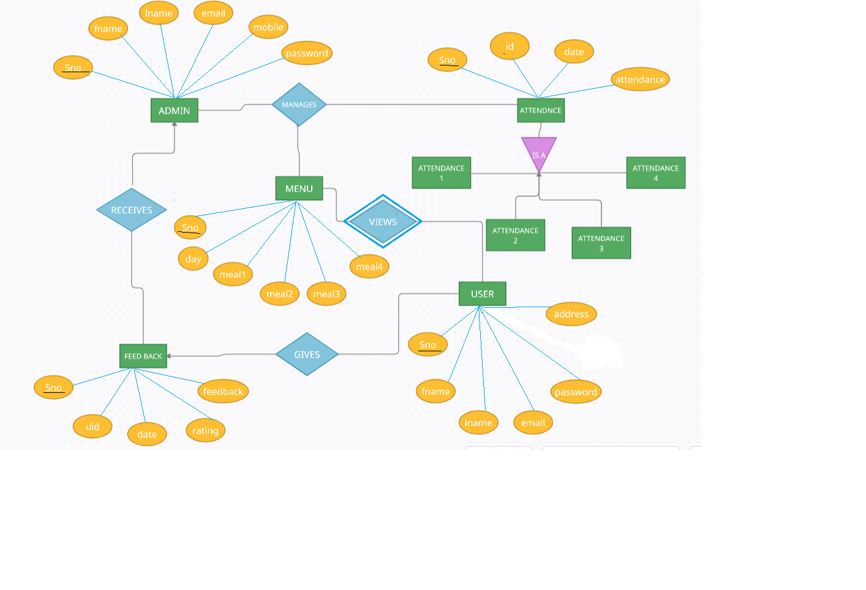

**SCREENSHOTS OF THE PROJECT**

**HOME PAGE**

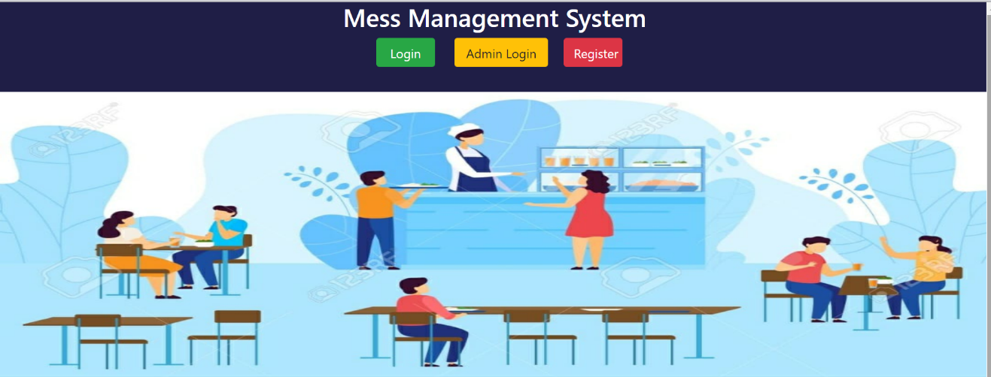

**USER INTERFACE**

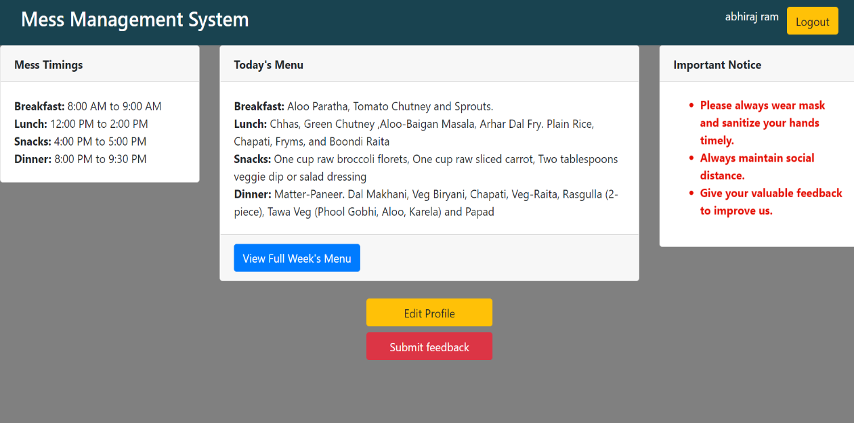

**USER FEEDBACK FUNCTIONALITY**

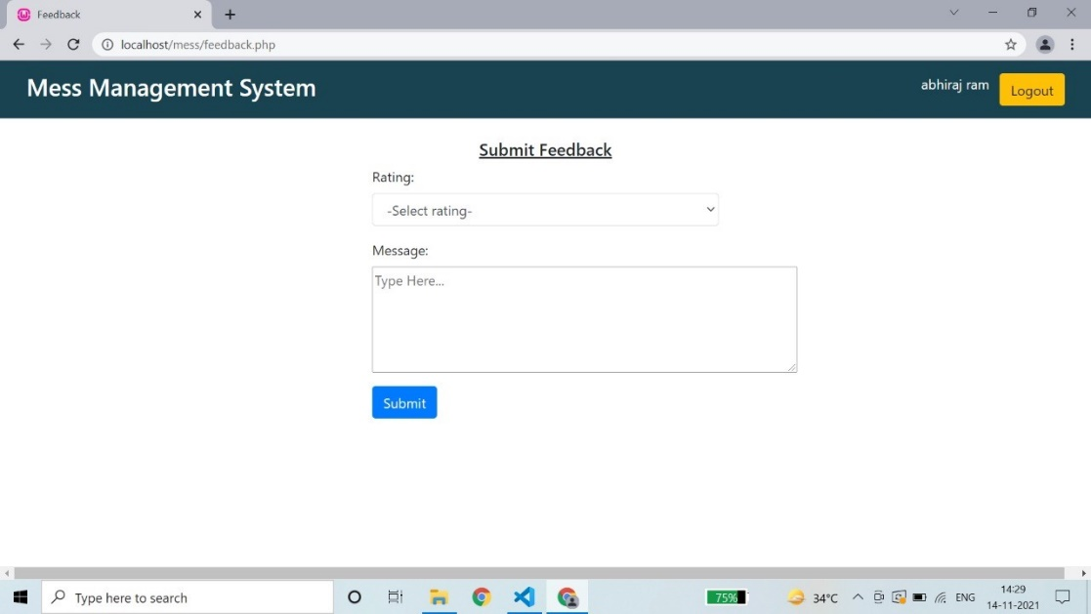

**ADMIN INTERFACE**

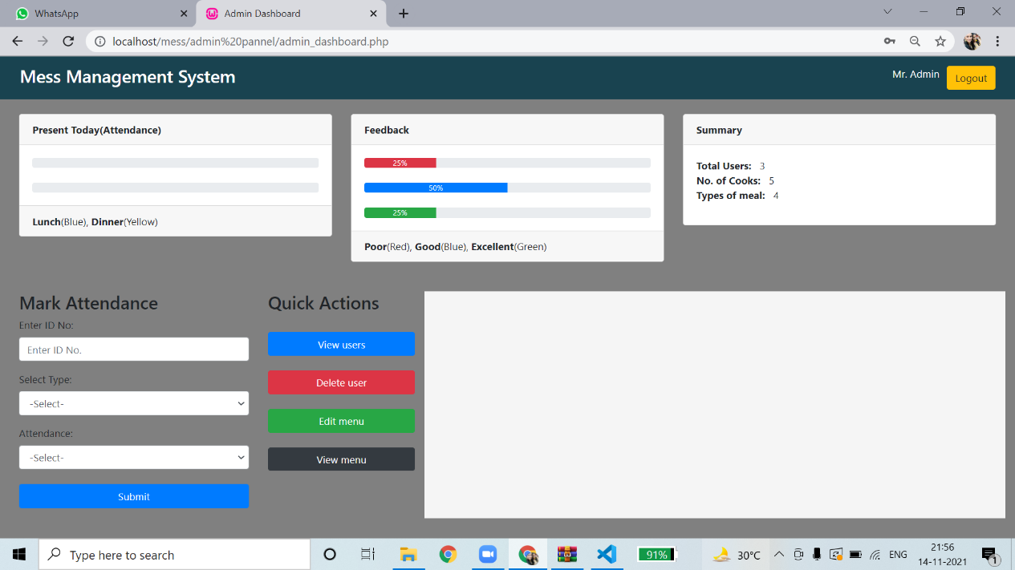

**VIEW USER FUNCTIONALITY**

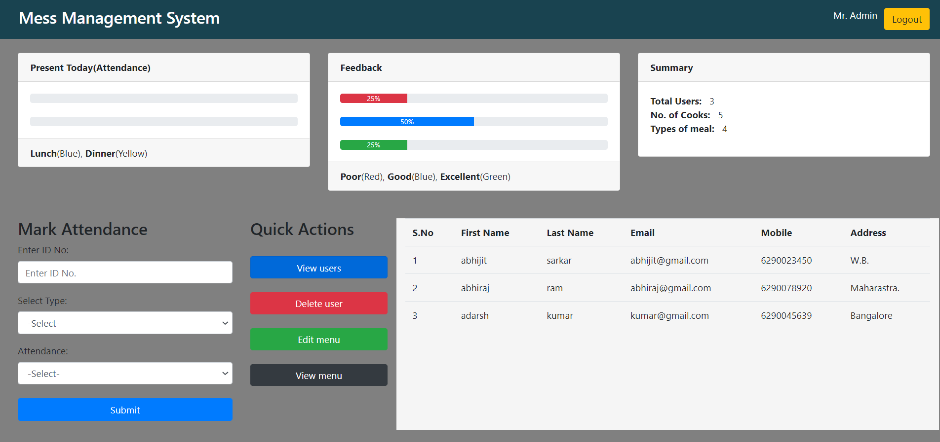

**EDIT MENU FUNCTIONALITY**

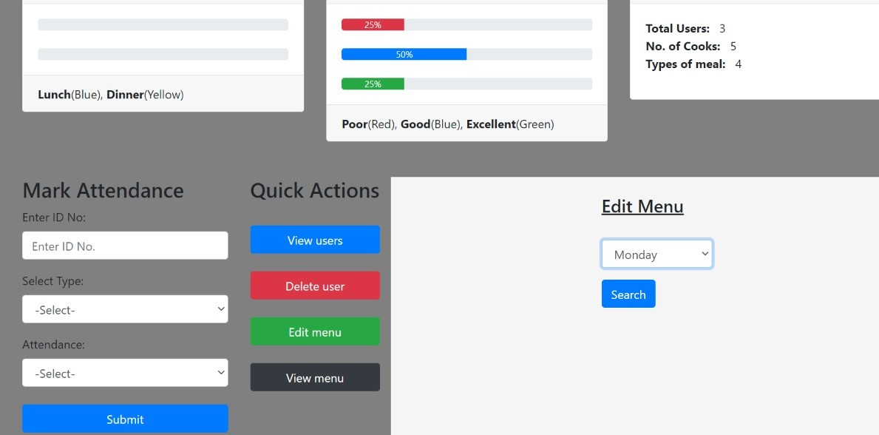

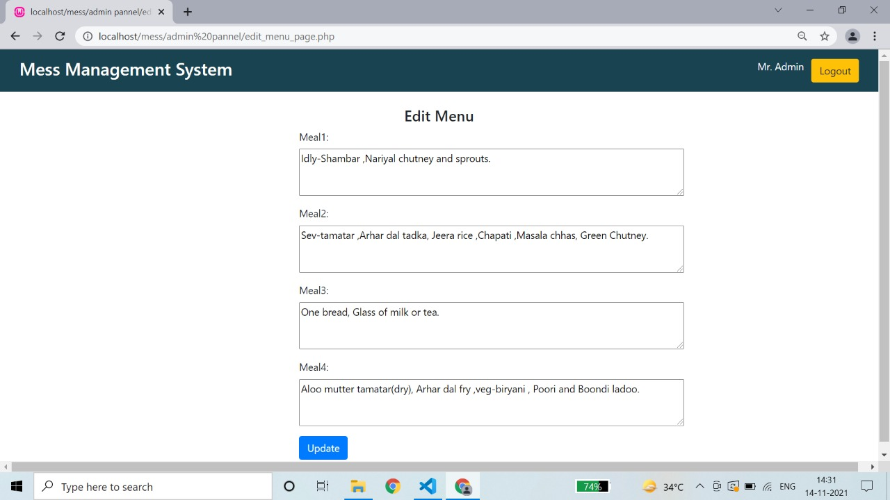

**Conclusion**

This project can be useful to any college hostel maintaining a mess or canteen. Security is maintained as the complete control of the system is only under the hands of an authorized person , i.e., Admin. It will enable mess managers to refer diet charts and plan. It will also enable admin to mark the attendance of a user to identify unauthorized person.